**Truss Bridge System Optimization**

**EGR 7040 *Design Optimization*, Wright State University**

Joseph Strzelecki and Admir Makas

***Abstract***

*Objective of the subject report is to illustrate the use optimization techniques to efficiently design a truss bridge used by foot and vehicular traffic. Trusses are widely used in civil and structural community to realize very complex systems. Trusses are incorporated in many structures such as bridges, buildings, airplane fuselage and wings. Goal is to design a bridge, which spans a 9 meter (~30 foot) ravine that will sustain design loads while minimizing bridge mass. By reducing mass it is directly possible to reduce cost, which is desirable in a day and age where resources are becoming increasingly sparse. Additionally, use of optimization lends a scientific technique that systematically leads to an optimum design. This helps to reduce design time and further minimizes costs. In order to calculate bridge stresses, finite element analysis (FEA) was implemented in conjunction with the optimization function FMINCON available in MATLAB. This technique was successful in generating an optimum design of the bridge system for different types of steel available in the market. Analysis shows that choosing the lightest design option does not necessarily yield the cheapest design. Reason for this is the cost variability between different steel types and will be discussed in detail.*

**1. Introduction**

Term truss was originally derived from the French term *trousse,* which means a *collection of things bound together* [3]. In simplest terms a truss is a two-force member, which allows for external load and reactions to take place at the ends of the truss members [1, 2, 4]. This definition implies that no moment loads are sustained by the truss members. As such, the joints at the member ends are assumed to be revolute. This condition is especially important for straight truss members. A collection of truss elements forms the truss system [1, 2, 4]. All truss systems can be generally categorized into two groups as plane and space trusses. Plane trusses are defined in a two-dimensional plane. This definition is appropriate when all the loads act in the plane either horizontally or vertically and any out of plane reactions are either zero or insignificant. On the other hand, space trusses are defined in three-dimensional space and are necessary when out of plane loads need to be accounted for [1, 2]. A typical plane and space truss configurations can be seen in Figure 1.

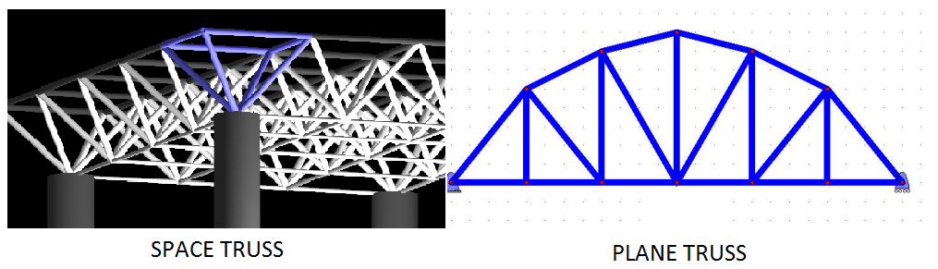

Figure 1: Truss types.

In structural and civil engineering, trusses are commonly used in many applications in order to realize the final vision of the desired structure. Trusses are inherently simple to construct, and they are extensively used across many disciplines to generate very complex systems. These disciplines include, but are not limited to: aerospace fuselages and wings, bridges, and skyscrapers. For these applications, the mass of the realized structures is a critical design parameter. Design optimization principles can be applied to minimize the mass and cost of the structure while maintaining sufficient strength and stiffness. Some examples of truss usage can be seen in Figure 2.

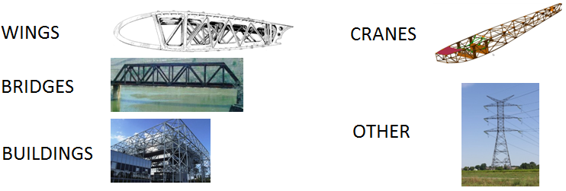

Figure 2: Truss applications in engineering

The goal of this project is to use optimization principles to design a truss bridge subject to foot and vehicular traffic. While simple in nature, bridges can be very complex structural systems that require a multi-disciplinary approach to achieve a successful product. In general, bridge design considerations are subject to loading requirements, thermal expansion, vibrations due to wind loading, stiffness, and environmental degradation. Work presented here will predominantly be concerned with optimizing bridge mass while maintaining loading requirements. Detail

s shall now be discussed in following sections.

**2. Problem Description**

Following section describes the bridge dimensions chosen for the optimization study along with loading requirements. Brief section will be devoted to outlining the finite element analysis (FEA) method, which is utilized to calculate stresses in the truss members. Next, materials chosen for the analysis are briefly discussed. Finally, the optimization problem is defined and solution methodology is identified.

**2.1 Bridge Definition**

The bridge chosen for the study comprises of truss members formed into equilateral triangles. This type of truss design is more commonly known as a *Warren Truss* [1, 2, 4]. Length of each truss element is set to be 3 meters long. This is a typical truss dimensions found in engineering statics texts [4]. Using the specified dimension will yield a bridge of 9 meters in length. This is a relatively short bridge design and is intended to span a small ravine or river. The intent of the proposed bridge is to allow crossing of commercial and private vehicles along with any potential foot traffic. Due to loading and stiffness requirements, the goal is to design a bridge that can hold *5000 kN* applied at two locations on the mid-span. Final bridge proposal can be seen below in Figure 3.

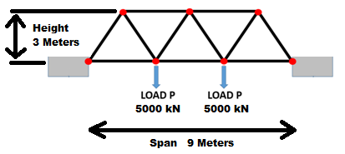

Figure 3: Bridge dimensions

The proposed bridge consists of 11 truss members and 7 joints. Since the applied load acts vertically in the plane, it is appropriate to assume a planar truss analysis. Furthermore, the span is relatively short at 9 meters so any cross wind loading will be insignificant when compared to the vertical loading requirements. As such it is safe to assume that the out of plane loading is negligible.

**2.2 Finite Element Analysis Overview**

Finite element analysis is widely used across a broad range of engineering fields to include but is not limited to structural, acoustic, thermal, fluid, material and electrical engineering. In general, if there exist governing partial differential equations (PDE’s) for a particular phenomenon then FEA technique can be applied. Specific to the proposed problem, FEA analysis is applied using truss element formulation to calculate truss member stresses. This is a critical step since optimization constraints will depend on the calculated stresses.

Next is presented a short overview of truss element formulation used for the FEA analysis. Since the problem is of planar truss type, the truss elements considered will allow for 2-D displacements. Figure 4 illustrates a typical truss element definition.

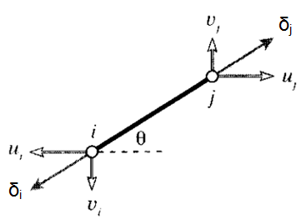

Figure 4: Truss element definition

Here the truss element is allowed to displace at nodes *i* and *j* as seen in Figure 4. Notice that node displacements *δi* and δj are along the local element coordinates that usually require one of the basis vectors to be along the element length. The goal is to resolve the nodal displacement in local coordinates to global coordinates. This is done via the rotation matrix as seen in Figure 5.

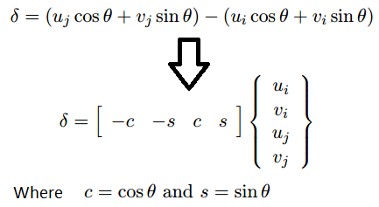

Figure 5: Node displacement defined in global coordinates.

Once the nodal displacements are expressed in global coordinates it is possible to formulate the relationship between nodal displacements and forces as $\overline{K}\overline{U}= \overline{F}$. In this tensor notation, $\overline{K}$ is denoted as the element stiffness matrix and comprises of physical properties that enable a linear mapping between displacement vector $\overline{U}$ and force vector $\overline{F}$. Explicitly this equation can be expressed as Figure 6 [7, 9].

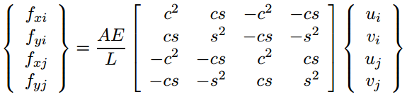

Figure 6: Truss element force displacement relationship.

Terms A, E, and L correspond to cross-sectional area, Young’s Modulus, and element length respectively. At this stage, it is possible to define the expression for all the elements in the model (in this case 11 elements). Once each element is defined per equation in Figure 6, each of the 11 expressions in assembled into the global stiffness matrix. When assembling the global stiffness matrix that represents the entire structure, it is important that force equilibrium and displacement compatibilities are maintained. Finally the problem can be solved by inverting the global stiffness matrix to obtain following expression that solves for nodal displacements $\overline{U}= {\overline{K}}^{-1}\overline{F}$. Knowing the displacements allows for calculation of elements strains that are used to calculate element stresses via constitutive relationship (i.e. Young’s Modulus, E).

The FEA method was implemented in MATLAB and the subject code can be seen in Appendix A. Before using the FEA solver for optimization, its accuracy was confirmed using commercial FEA software ABAQUS. Model geometry follows the definition in Figure 3 and Table 1 lists the material and geometrical properties used.

|  |  |
| --- | --- |
|  | **Model Properties** |
| Young’s Modulus, E | 200 GPa |
| Poisson’s Ratio, ν | 0.30 |
| Cross-Section Area | 0.020 m2 |
| Element Length | 3 m |
| Load, L | 5000 kN |

Table 1: Model properties.

Steel material properties were obtained from a popular mechanics of materials textbook while geometrical properties were derived from problem definition in Figure 3 [8]. Table 2 lists stress results from the MATLAB solver and ABAQUS, which agree quite well. Letter “C” denotes truss elements in compression and “T” identifies elements in tension.

|  |  |  |
| --- | --- | --- |
| **Stress Results for Matlab and ABAQUS analysis** | | |
| **Element #** | **Matlab Stress** | **ABAQUS Stress** |
| 1 | 288.7 MPa, C | 288.7 MPa, C |
| 2 | 288.7 MPa, C | 288.7 MPa, C |
| 3 | 48.1 MPa, C | 48.1 MPa, C |
| 4 | 96.2 MPa, T | 96.2 MPa, T |
| 5 | 48.1 MPa, C | 48.1 MPa, C |
| 6 | 288.7 MPa, C | 288.7 MPa, C |
| 7 | 288.7 MPa, T | 288.7 MPa, T |
| 8 | 0 MPa | 0 MPa |
| 9 | 0 MPa | 0 MPa |
| 10 | 288.7 MPa, T | 288.7 MPa, T |
| 11 | 288.7 MPa, C | 288.7 MPa, C |

Table 2: FEA stress results for MATLAB and ABAQUS solvers.

To better visualize the stress results, Figure 7 illustrates results from ABAQUS with each element labeled.

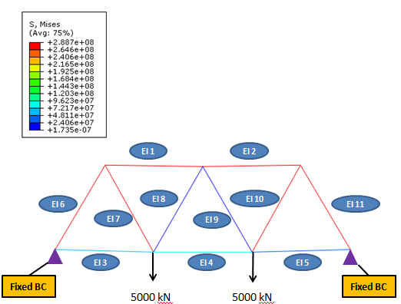

Figure 7: ABAQUS plot results.

Table 2 shows that MATLAB FEA solver is accurate for the proposed problem and can be used for the optimization procedure. FEA model for the proposed bridge system is illustrated in Figure 8, which shows model nodes elements and boundary conditions (displacement, load).

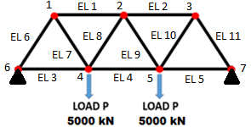

Figure 8: FEA model for bridge design optimization.

**2.3 Material Selection**

Almost universally, steel is the choice of material used for bridge construction. Typically, steel alloy grades can be specified via chemical composition or mechanical strength properties such as yield strength (σy). Since yield strength will be the constraint on the bridge design, following steel grades were chosen for the study.

|  |  |  |
| --- | --- | --- |
| **Steel Data** | | |
| **Steel Nomenclature** | **Yield Strength** | **Price per Ton** |
| 270 Steel | 270 MPa | $550.00 |
| 340 Steel | 340 Mpa | $650.00 |
| 420 Steel | 420 Mpa | $700.00 |
| 550 Steel | 550 Mpa | $950.00 |

Table 3: Steel properties and costs [5, 6].

The values listed in the table above were obtained through material specifications and current steel prices listed by vendors on-line [5, 6]. It should be noted that steel prices can vary significantly in short period of time so quoted prices above may not be accurate a month from now. Other material properties required are listed in Table 4 [5, 8].

|  |  |
| --- | --- |
|  | **Model Properties** |
| Young’s Modulus, E | 200 GPa |
| Poisson’s Ratio, ν | 0.30 |
| Density, ρ | 7850 $\frac{kg}{m^{3}}$ |

Table 4: Additional material properties [5, 8]

**2.4 Optimization Problem Statement**

Cost function will be the total mass of the bridge, which is the summation of each individual truss members defined below:

$M= ρ\sum_{i=1}^{11}{A_{i}L_{i}}$, where

* $M$ = Bridge mass, kilograms
* $A_{i}$ = Cross-section area of each truss (**design variable**), *meters2*
* = Length of each truss element, *meters*
* $ρ$ = material density, $\frac{kg}{m^{3}}$

Element lengths are to remain constant since the bridged ravine is not changing. Therefore, the design variable in the formulation will be the cross-sectional areal of each truss element. The structure is required to withstand a load of 5000 kN at two locations on the mid-span as illustrated in Figure 3 while requiring that material response remain elastic. This will ensure that no permanent deformation is present in the bridge. As such the constraints will require that each truss element not exceed yield stress $σ_{y}$ in either compression or tension. Yield limits can be found in Table 3. Stress constraints are defined below:

$σ_{T_{i}}= \frac{σ_{i}}{σ_{y}}≤1$, Tensile stress constraint

$σ_{C_{i}}= \frac{σ_{i}}{σ_{y}}≤1$, Compression stress constraint

* $σ_{T_{i}}$ = Element tensile stress constraint
* $σ_{C_{i}}$ = Element compressive stress constraint
* $σ_{i}$ = Element stress, Pa
* $σ_{y}$ = Allowable element stress, in this case yield strength, Pa

Since the structure is comprised of 11 truss elements there will be 22 total stress constraints (2 per element). Design variable $A_{i}$ is used in the stress calculation as defined in Figure 6. Additionally, in order to have a feasible design, limits must be imposed on the design variable $A_{i}$ to ensure that truss elements are not unrealistically thick. Furthermore, negative values are not allowed. This side constraint is simply expressed as:

$$LB≤A_{i}≤UB$$

Finally the problem can be stated in standard form seen below:

**Minimize:**

$M= ρ\sum_{i=1}^{11}{A_{i}L_{i}}$

**Subject to:**

$σ_{T_{i}}= \frac{σ_{i}}{σ_{y}}≤1$

$σ_{C_{i}}= \frac{σ_{i}}{σ_{y}}≤1$

$LB≤A_{i}≤UB$, $A_{i}$ bounds: [0.0001 – 0.070]m2

Bounds for $A_{i}$ were chosen to yield a truss of 10X10 mm on low end. This would signify that trusses of this dimension would not be load bearing. On the opposite end, max truss dimension would be 265X265 mm. Truss thickness greater than this would make it difficult to handle and connect to neighboring trusses.

While the cost function is linear, the corresponding stress constraints are not. Therefore, MATLAB function FCONMIN was used for the optimization procedure. This method is appropriate for the problem definition above and yielded very smooth iteration history. No gradient functions were provided at the initial input. Rather, it was decided to allow the FMINCON subroutine to calculate the appropriate gradients using the finite difference procedure.

**3.0 Optimization Results**

To start the optimization procedure, initial $A_{i}$ chosen is 0.02 m2 for each element. Optimization subroutine was executed for each of the materials listed in Table 3. Each optimization run converged in 11 iterations in a smooth manner. Iteration history for the four runs is summarized in Figure 8.

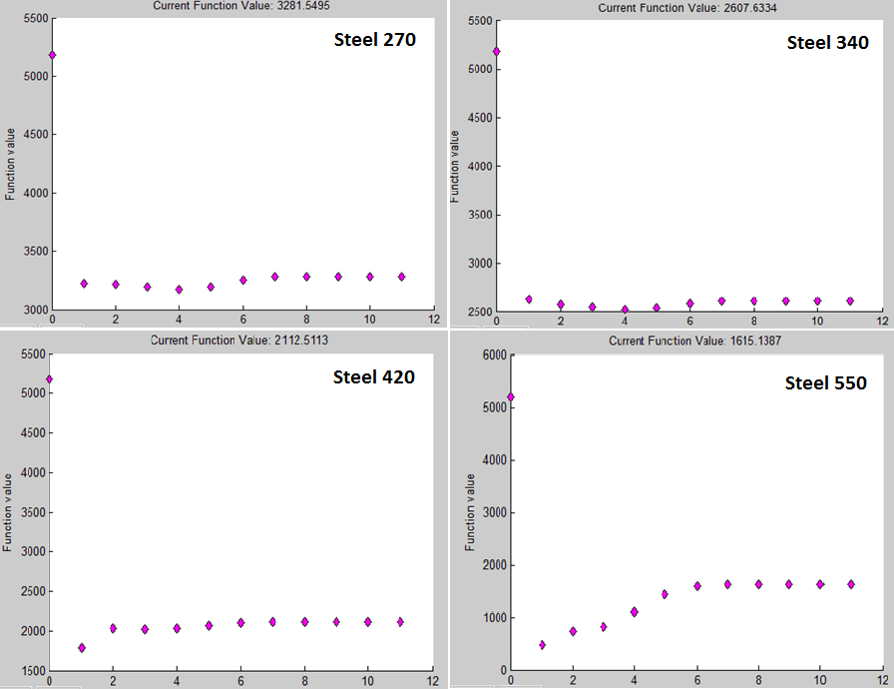

Figure 9: Optimization iteration history

Next, Table 5 shows the optimized $A_{i}$ values. It can be observed that as steel yield strength is increased optimized cross-section areas reduce in value. This makes sense since stronger materials can withstand higher stresses before plasticity occurs.

|  |  |  |  |  |  |
| --- | --- | --- | --- | --- | --- |
| **Element ID** | **Initial** | **Steel 270 (m2)** | **Steel 340 (m2)** | **Steel 420 (m2)** | **Steel 550 (m2)** |
| 1 | 0.020 | 0.021 | 0.017 | 0.014 | 0.011 |
| 2 | 0.020 | 0.021 | 0.017 | 0.014 | 0.011 |
| 3 | 0.020 | 0.0001 | 0.0001 | 0.0001 | 0.0001 |
| 4 | 0.020 | 0.011 | 0.008 | 0.007 | 0.005 |
| 5 | 0.020 | 0.0001 | 0.0001 | 0.0001 | 0.0001 |
| 6 | 0.020 | 0.021 | 0.017 | 0.014 | 0.011 |
| 7 | 0.020 | 0.021 | 0.017 | 0.014 | 0.011 |
| 8 | 0.020 | 0.0001 | 0.0001 | 0.0001 | 0.0001 |
| 9 | 0.020 | 0.0001 | 0.0001 | 0.0001 | 0.0001 |
| 10 | 0.020 | 0.021 | 0.017 | 0.014 | 0.011 |
| 11 | 0.020 | 0.021 | 0.017 | 0.014 | 0.011 |

Table 5: Optimized values for $A_{i}$ for 4 steel variants.

Each of the material columns have only 3 distinct area values. This is attributed to the geometric and loading symmetry present in the bridge design. It is also important to note that while the optimized result indicates elements 3, 5, 8, and 9 have very small *A*, they cannot be removed entirely from the bridge design since asymmetries and instabilities will be introduced. They can however be made very thin. Finally, it can be observed that optimized cross-section areas are within the defined bounds of the optimization problem. Next variable of interest is the resultant stresses in the truss members, which can be viewed in Table 6.

|  |  |  |  |  |  |
| --- | --- | --- | --- | --- | --- |
| **Truss Elements Stresses expressed as 1.0*e8 Pa** | | | | | |
| **Element ID** | **Initial Stress** | **Steel 270** | **Steel 340** | **Steel 420** | **Steel 550** |
| 1 | -2.887 | -2.700 | -3.400 | -4.200 | -5.500 |
| 2 | -2.887 | -2.700 | -3.400 | -4.200 | -5.500 |
| 3 | -0.481 | -1.350 | -1.700 | -2.100 | -2.750 |
| 4 | 0.962 | 2.700 | 3.400 | 4.200 | 5.500 |
| 5 | -0.481 | -1.350 | -1.700 | -2.100 | -2.750 |
| 6 | -2.887 | -2.700 | -3.400 | -4.200 | -5.500 |
| 7 | 2.887 | 2.700 | 3.400 | 4.200 | 5.500 |
| 8 | 0.000 | 0.000 | 0.000 | 0.000 | 0.000 |
| 9 | 0.000 | 0.000 | 0.000 | 0.000 | 0.000 |
| 10 | 2.887 | 2.700 | 3.400 | 4.200 | 5.500 |
| 11 | -2.887 | -2.700 | -3.400 | -4.200 | -5.500 |

Table 6: Stress results from the optimization output.

Results in Table 6 show that as constraint limits are increased for higher yield steel variants the optimizer succeeds at reaching the constraint boundary for a selected group of elements (elements 1, 2, 4, 6, 7, 10, 11). In fact the stress constraints are active for the aforementioned elements. Stress results also support results in Table 5, which show very small stress response in element that effectively have zero cross-sectional area (elements 3, 5, 8, 9). It should be noted that negative signs denote a truss element in compression.

Table 7 contains constraint values, which serve to confirm that the achieved optimum design is feasible. Constraint values are tabulated for tension and compression. Goal is to have the constraint value be ≤ 0. Any positive value signifies a violated constraint. Out of the four steel types, only steel 270 initially violated the constraint requirements as indicated by the positive values. Remaining steel grades had no initial constraint violations

|  |  |  |  |  |  |  |  |  |
| --- | --- | --- | --- | --- | --- | --- | --- | --- |
| **Stress Constraint Values** | | | | | | | | |
|  | **Steel 270 Const. Values** | | **Steel 340 Const. Values** | | **Steel 420 Const. Values** | | **Steel 550 Const. Values** | |
|  | **Initial** | **Final** | **Initial** | **Final** | **Initial** | **Final** | **Initial** | **Final** |
| **Tensile** | -2.07 | -2.00 | -1.85 | -2.00 | -1.69 | -2.00 | -1.52 | -2.00 |
| -2.07 | -2.00 | -1.85 | -2.00 | -1.69 | -2.00 | -1.52 | -2.00 |
| -1.18 | -1.50 | -1.14 | -1.50 | -1.11 | -1.50 | -1.09 | -1.50 |
| -0.64 | 0.00 | -0.72 | 0.00 | -0.77 | 0.00 | -0.83 | 0.00 |
| -1.18 | -1.50 | -1.14 | -1.50 | -1.11 | -1.50 | -1.09 | -1.50 |
| -2.07 | -2.00 | -1.85 | -2.00 | -1.69 | -2.00 | -1.52 | -2.00 |
| 0.07 | 0.00 | -0.15 | 0.00 | -0.31 | 0.00 | -0.48 | 0.00 |
| -1.00 | -1.00 | -1.00 | -1.00 | -1.00 | -1.00 | -1.00 | -1.00 |
| -1.00 | -1.00 | -1.00 | -1.00 | -1.00 | -1.00 | -1.00 | -1.00 |
| 0.07 | 0.00 | -0.15 | 0.00 | -0.31 | 0.00 | -0.48 | 0.00 |
| -2.07 | -2.00 | -1.85 | -2.00 | -1.69 | -2.00 | -1.52 | -2.00 |
| **Compression** | 0.07 | 0.00 | -0.15 | 0.00 | -0.31 | 0.00 | -0.48 | 0.00 |
| 0.07 | 0.00 | -0.15 | 0.00 | -0.31 | 0.00 | -0.48 | 0.00 |
| -0.82 | -0.50 | -0.86 | -0.50 | -0.89 | -0.50 | -0.91 | -0.50 |
| -1.36 | -2.00 | -1.28 | -2.00 | -1.23 | -2.00 | -1.18 | -2.00 |
| -0.82 | -0.50 | -0.86 | -0.50 | -0.89 | -0.50 | -0.91 | -0.50 |
| 0.07 | 0.00 | -0.15 | 0.00 | -0.31 | 0.00 | -0.48 | 0.00 |
| -2.07 | -2.00 | -1.85 | -2.00 | -1.69 | -2.00 | -1.52 | -2.00 |
| -1.00 | -1.00 | -1.00 | -1.00 | -1.00 | -1.00 | -1.00 | -1.00 |
| -1.00 | -1.00 | -1.00 | -1.00 | -1.00 | -1.00 | -1.00 | -1.00 |
| -2.07 | -2.00 | -1.85 | -2.00 | -1.69 | -2.00 | -1.52 | -2.00 |
| 0.07 | 0.00 | -0.15 | 0.00 | -0.31 | 0.00 | -0.48 | 0.00 |

Table 7: Constraint values

No constraints are violated at the optimum point for all steel grades. Note that values of zero indicate active constraints.

Knowing that the design optimization results are feasible, cost values for the specified steel grades were used in conjunction with final mass values to calculate bridge costs. These results are tabulated in Table 8.

|  |  |  |  |
| --- | --- | --- | --- |
| **Optimization Summary** | | | |
| **Alloy Grade** | **Starting Mass (kg)** | **Ending Mass (kg)** | **Cost ($)** |
| 270 | 5181.0 | 3281.6 | 1805.00 |
| 340 | 5181.0 | 2607.6 | 1695.00 |
| 420 | 5181.0 | 2112.5 | 1479.00 |
| 550 | 5181.0 | 1615.0 | 1534.00 |

Table 8: Mass and cost results.

Final results show that steel grade 550 yields lightest design. This is expected due to the problem formulation. However, it did not yield the most cost efficient option. Steel 420 option, while being heavier, yields the cheapest design option at $1479.00. This is a result that would not have been immediately discernible without performing the optimization procedure. Steel grades 340 and 270 produce the costliest design due to the mass penalty incurred in order to maintain elastic behavior.

Finally, the optimized shape for the proposed bridge will take on the following shape for all the steel grades.

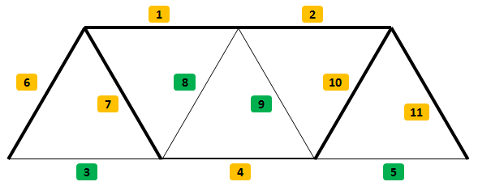

Figure 10: Optimized shape

Elements colored in orange indicate truss elements with active constraints. Elements colored in green have inactive stress constraints.

**4.0 Optimization Results**

Optimization analysis of a conventional truss bridge was carried out. Stress in the truss members was calculated via FEA technique that was employed inside MATLAB. Stress results obtained from MATLAB were confirmed by ABAQUS CAE software, which is a commercial package widely used in academia and industry.

FEA solver was used in conjunction with MATLAB function FMINCON to optimize the bridge design. Four steel grades were chosen for the study, each of which had its respective yield strength value. Stress constraints employed in the optimization analysis utilized individual yield strength values to define feasible design regions. Each optimization solve took 11 iterations to converge, which was smooth in nature. Due to geometrical and loading symmetries optimization results were also symmetric. Final optimization results have active stress constraints for certain group of elements. This was true for all steel grades. Additionally, the optimized results identified truss elements with low stresses. In these cases, their respective cross-section area was reduced to the lower limit of the side constraint. Low stress truss elements should remain in the bridge structure in order to ensure structural stability. However, their respective cross-section area footprint should be very small. Constraint values for all the design options were ≤ 0, which implies that optimization results remained in feasible space.

Optimized bridge mass for all steel grades were used to calculate total material costs. While steel grade 550 achieved lightest design, due to material costs it was not cost efficient. Steel grade 420, while heavier than 550 steel bridge, had the lowest material costs ($1479.00). This result is not immediately recognizable without performing the optimization procedure. Steel grades 270 and 340 were the cheapest options in terms of material cost. However, resultant bridge mass was enough to make them the costliest options in terms of total material costs.

In closing, optimization procedure was carried out with the aid of the FEA method. Project goal was to obtain the cheapest bridge design, which was achieved successfully.

**References**

1. Plesha, Michael E.; Gray, Gary L.; Costanzo, Francesco (2013). Engineering Mechanics: Statics (2nd ed.). New York: McGraw-Hill Companies Inc. ISBN 0-07-338029-6.
2. Ching, Frank. A Visual Dictionary of Architecture. 2nd ed. Hoboken, N.J.: Wiley, 2012. Print. ISBN 9780470648858
3. <http://www.etymonline.com/index.php?term=truss>
4. Hibbeler, Russell Charles (1983) [1974]. Engineering Mechanics-Statics (3rd ed.). New York: Macmillan Publishing Co., Inc. ISBN 0-02-354310-8.
5. Matweb.com (Steel Material Properties)
6. Alibaba.com (Material Pricing)
7. Kwon, Young W.; Bang Hyochoong (1997). The Finite Element Method Using MATLAB. Boca Raton, Florida: CRC Press LLC. ISBN 0-8493-9653-0.
8. Hibbeler, Russell C. Mechanics of Materials (6th ed). Lebanon Indiana: Prentice Hall. ISBN 0-1360-2230-8.
9. David Rolyance. Finite Element Analysis (2001). Cambridge, MA: MIT (Course Notes)

**Appendix A**

**M-file to initiate optimization procedure:**

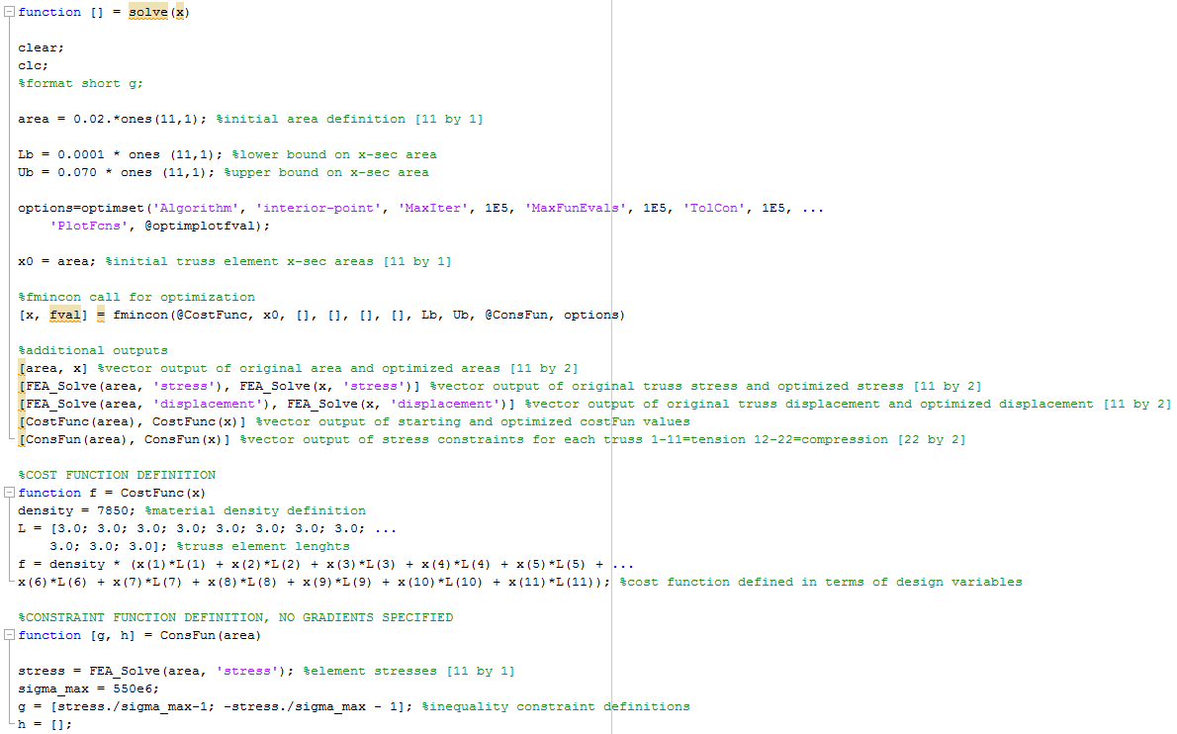

**FEA Solver:**

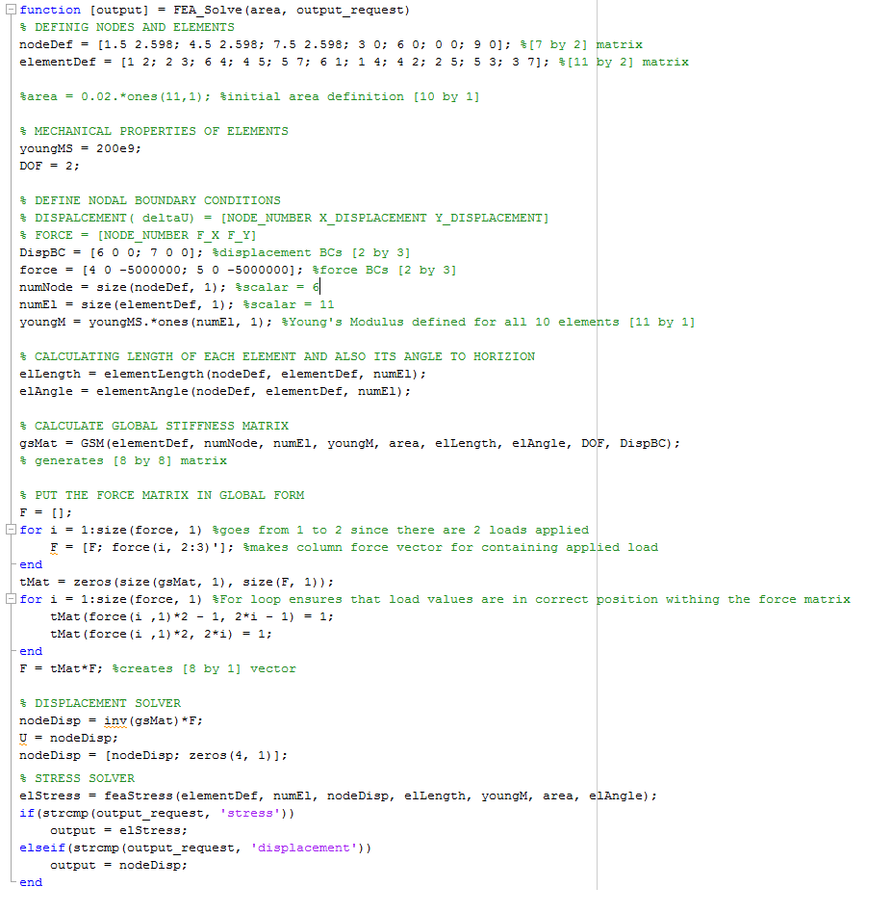

**Additional Support Files:**

